**Task 1:**

#include<bits/stdc++.h>

using namespace std;

int main(){

int size;

cout<<"enter the number of elements in array "<<endl;

cin>>size;

int arr[size];

cout<<"enter the elements in the array "<<endl;

for(int i=0;i<size;i++){

cin>>arr[i];

}

cout<<"the most repeated element is/are ";

for(int i=0;i<size;i++){

for(int j=i+1;j<size;j++){

if(arr[i]==arr[j]){

cout<<arr[i]<<" ";

}

}

}

return 0;

}

**Output:**

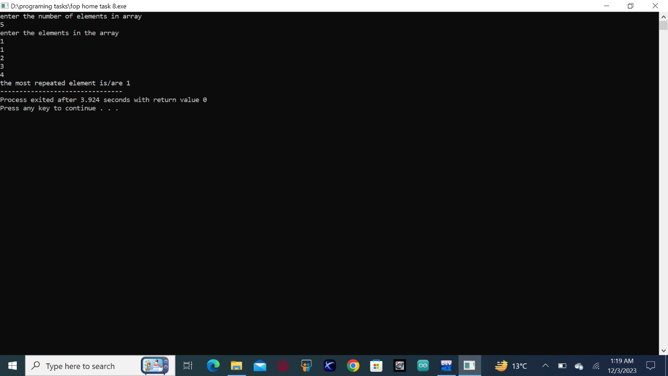

**Task 2:**

#include<bits/stdc++.h>

using namespace std;

int main(){

int size;

cout<<"enter your desired number of elements of array "<<endl;

cin>>size;

int arr[size],min=0,max=0;

cout<<"enter the desired values in the array "<<endl;

for( int i=0;i<size;i++){

cin>>arr[i];

}

for(int i=0;i<size;i++){

if(arr[i]<arr[min]){

min=i;

}

}

for(int i=0;i<size;i++){

if(arr[i]>arr[max]){

max=i;

}

}

cout<<"the smallest and largest ineteger in the array are "<<arr[min]<<" & "<<arr[max]<<" respectively"<<endl;

return 0;

}

**Output:**

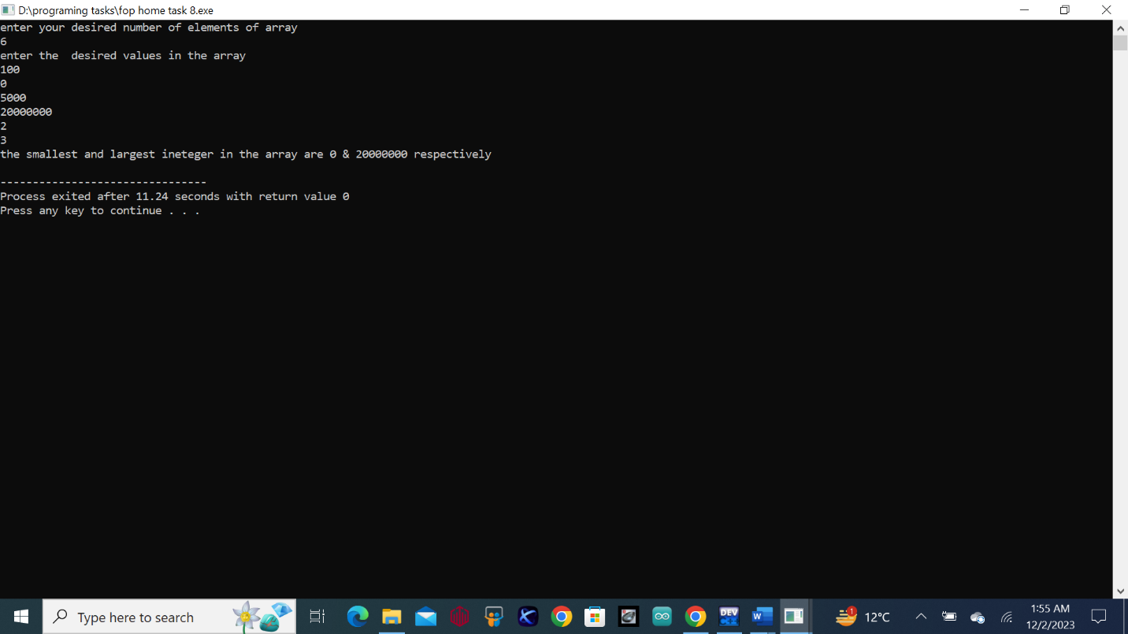

**Task 3:**

#include<bits/stdc++.h>

using namespace std;

int main(){

int size;

cout<<"enter the number of elements to make an array "<<endl;

cin>>size;

int arr[size];

cout<<"enter the elements in the array "<<endl;

for(int i=0;i<size;i++){

cin>>arr[i];

}

cout<<"the resulted entered array is "<<endl;

for(int i=0;i<size;i++){

cout<<arr[i];

}

cout<<endl;

int temp=arr[1];

arr[1]=arr[3];

arr[3]=temp;

cout<<"the resulted array with 2nd & 4th swapped positioned integers is "<<endl;

for(int i=0;i<size;i++){

cout<<arr[i];

}

return 0;

}

**Output:**

